**Assignment 3**

**Individual:**

* **Screenshot of the EER diagram**

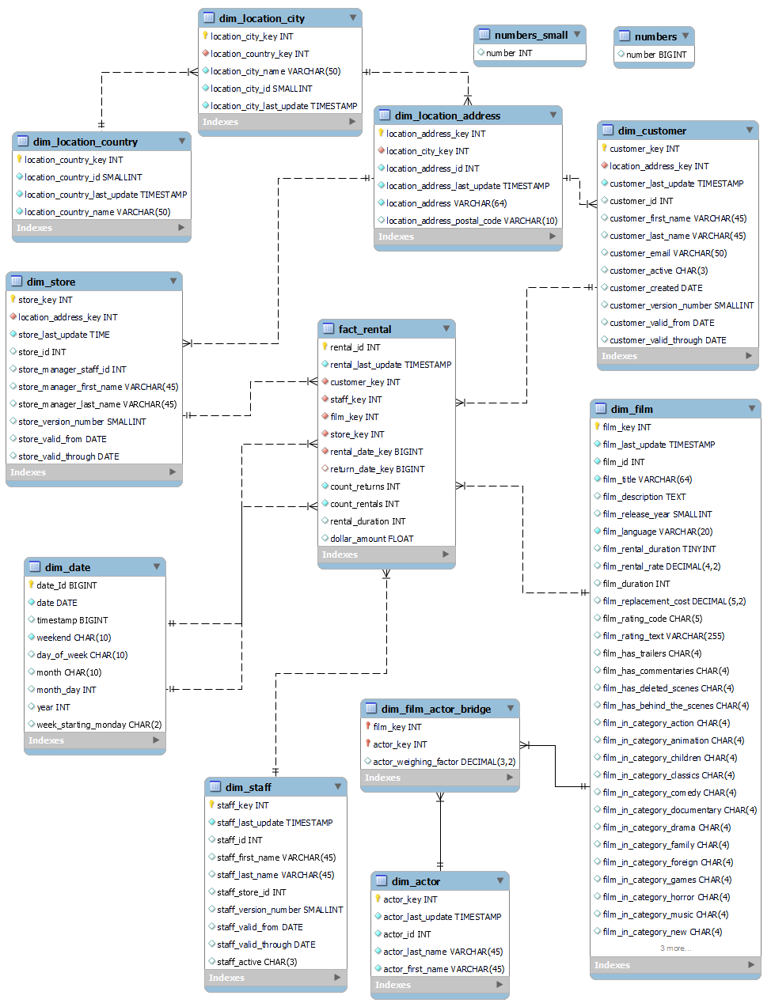

* **SQL (DDL/DML) queries used along with any assumptions & outputs (first few rows) for each question**
* 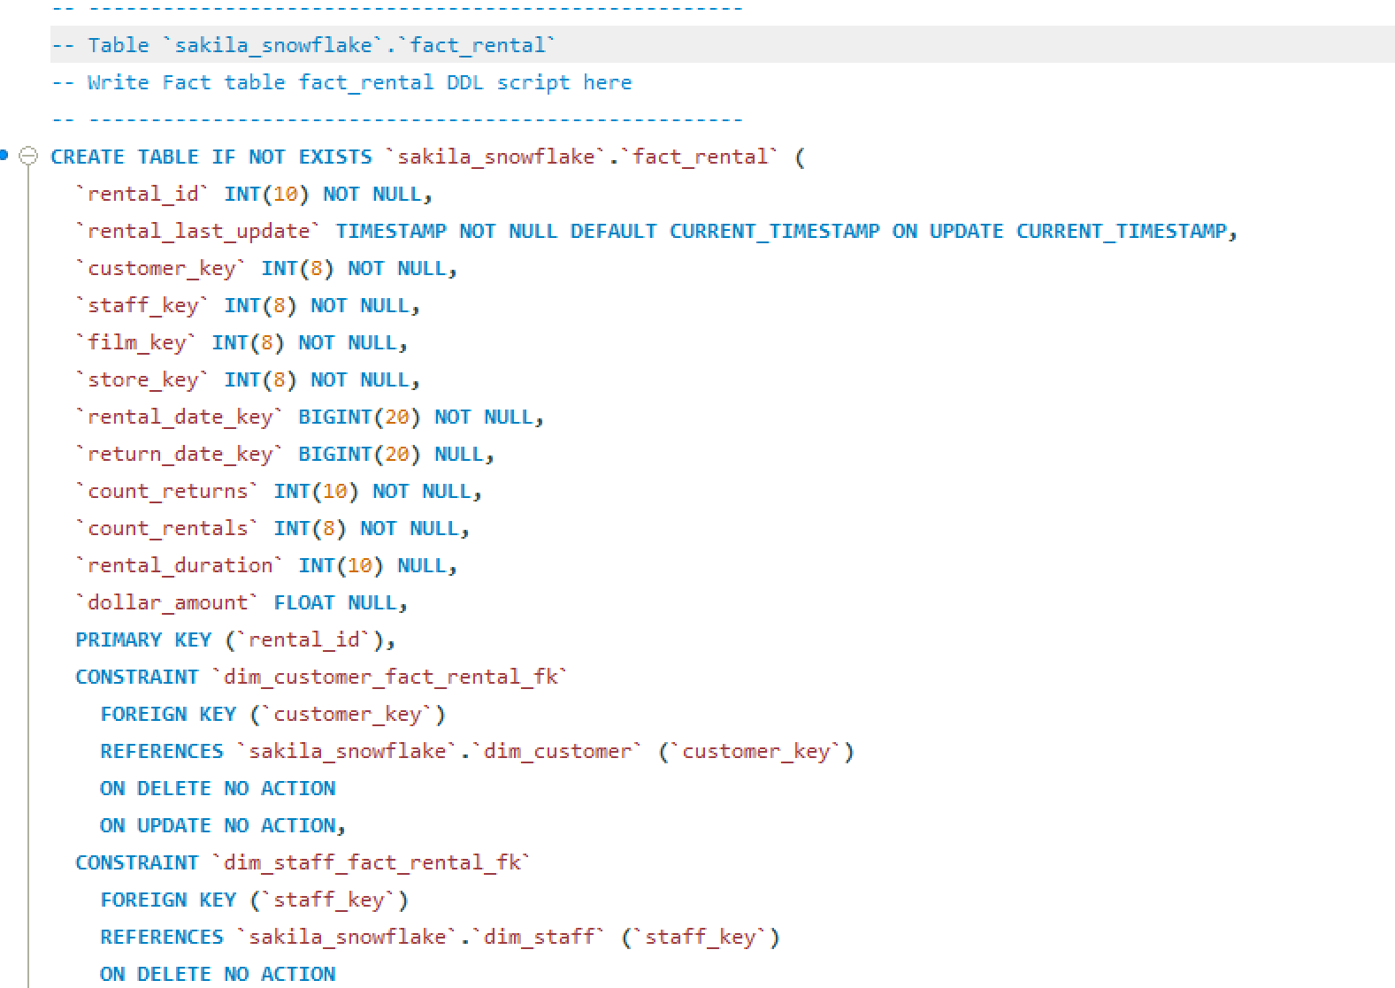**DDL:**

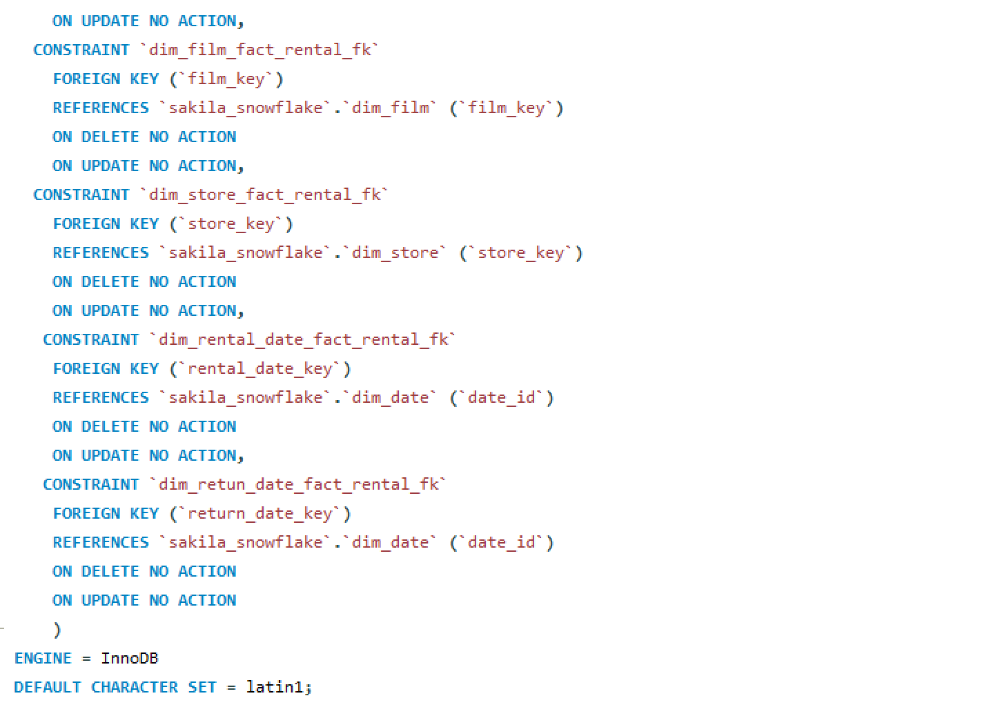

* **DML:**

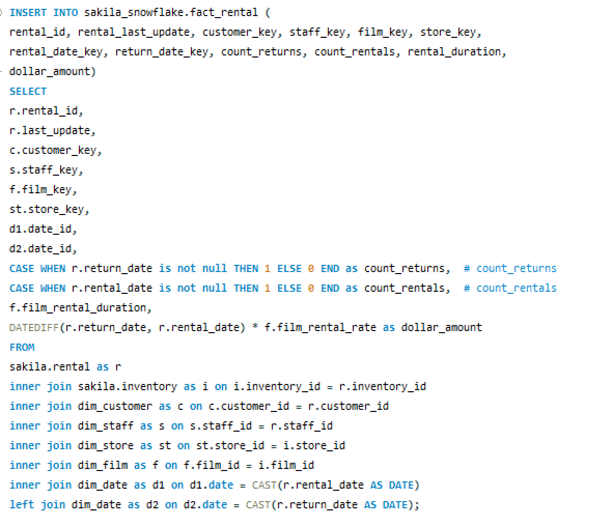

* **Assumptions:**

For the dollar_amount, if the return_date is null in the original rental table, then the dollar_amount would also be null. (use the datediff function and it would return null)

* **Output:**

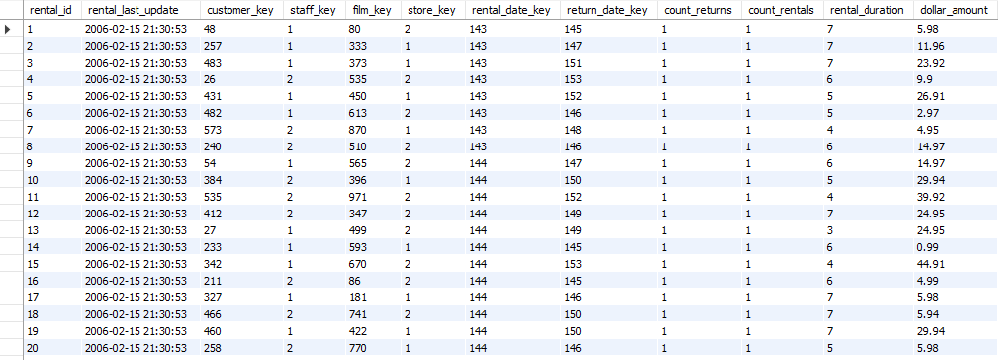

* **Identify any scripts errors and areas of improvement in the data model.**

1. In the DML script, the actor information is inserted twice into the dim_actor table.

Solution is to delete the duplicated insertion query.

1. The current approach to indicate the film category in the dim_film table is not very convenient.

it would be better to use a new column category_key (use different integers to represent different categories) instead of having these extra columns.

1. The current staff_key and store_key are not the same as their corresponding value in the old sakila table. (Mike Hillyer should have staff id of 1 and in the store with id 1, but it has store id 2 in the sakila_snowflake).

In the dim_store, it should use `staff_key` in dim_staff as the identifier for different staffs instead of the old manager_staff_id from sakila.staff. But this doesn’t have very important effect on the data.

* **Screenshots of all Tableau reports and dashboard(s)**
* 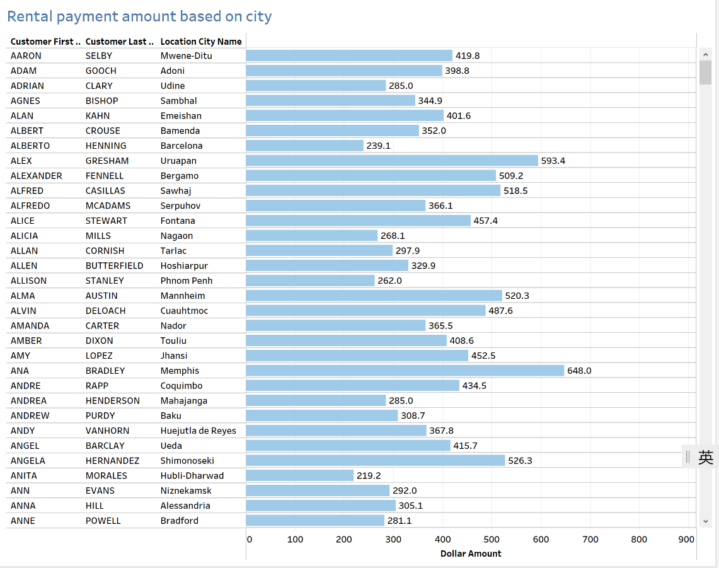**Reports**

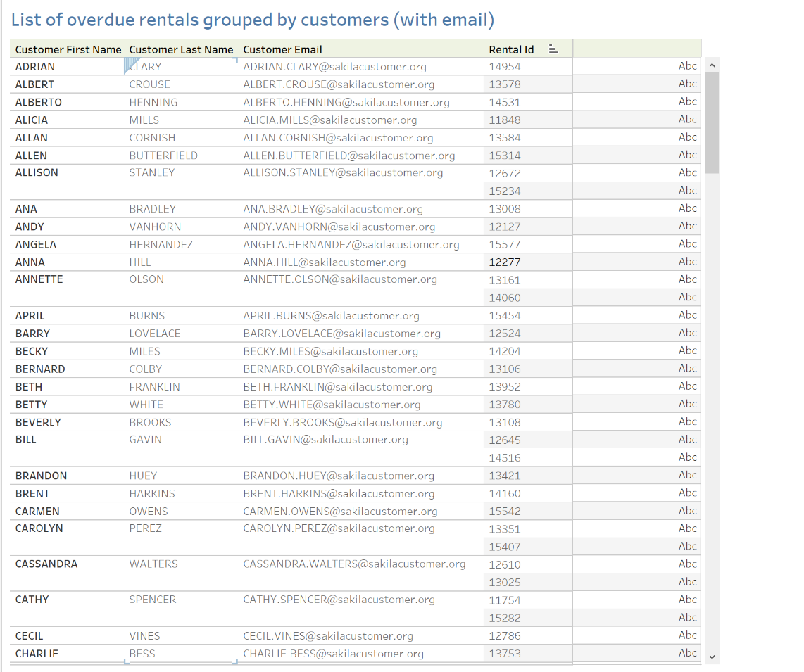

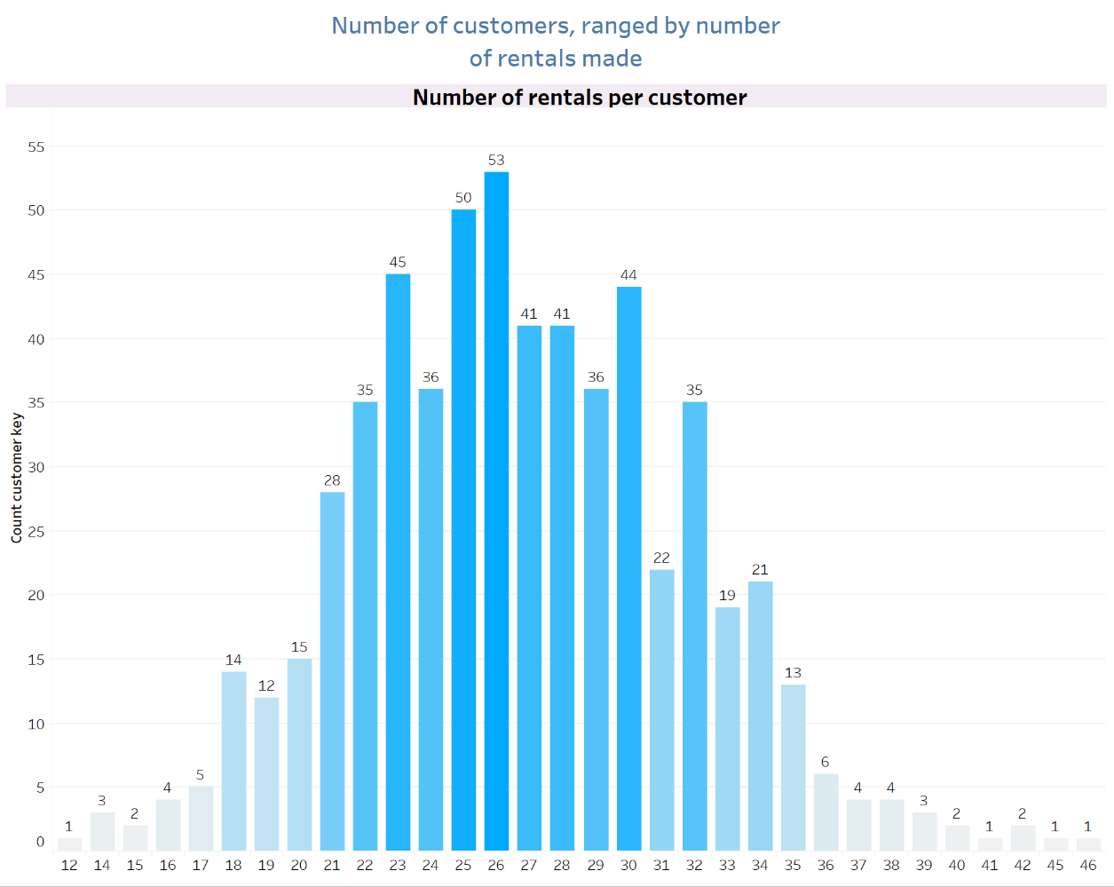

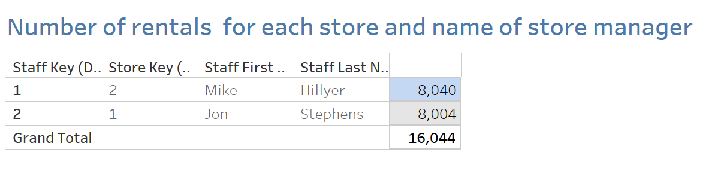

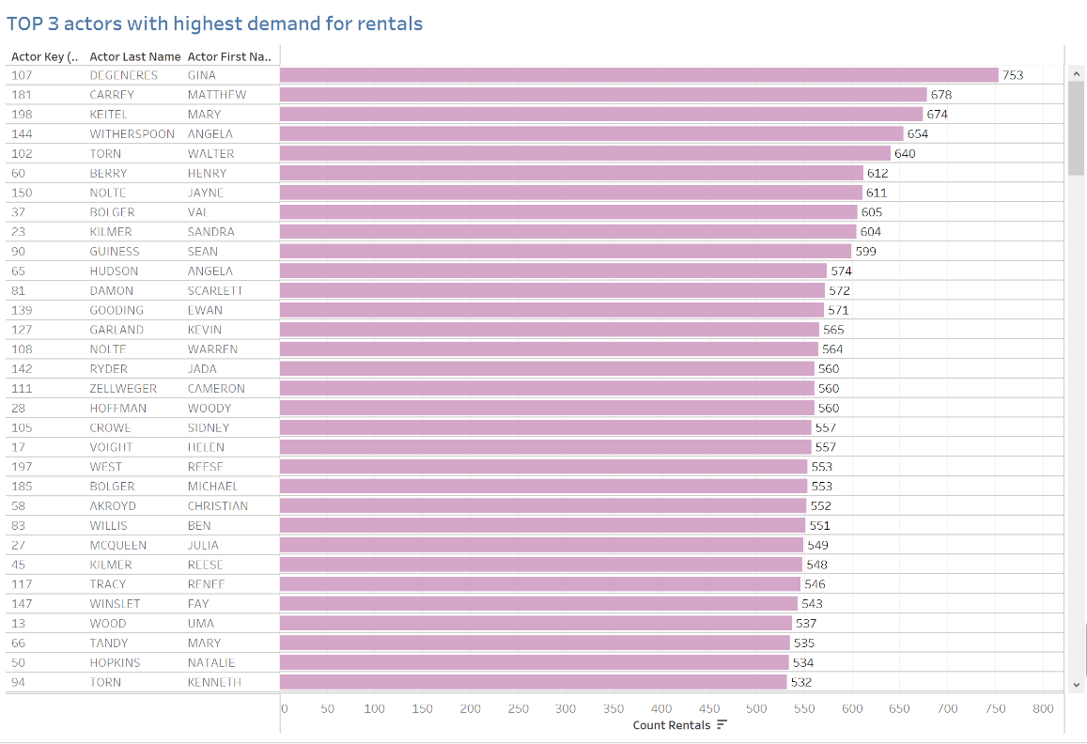

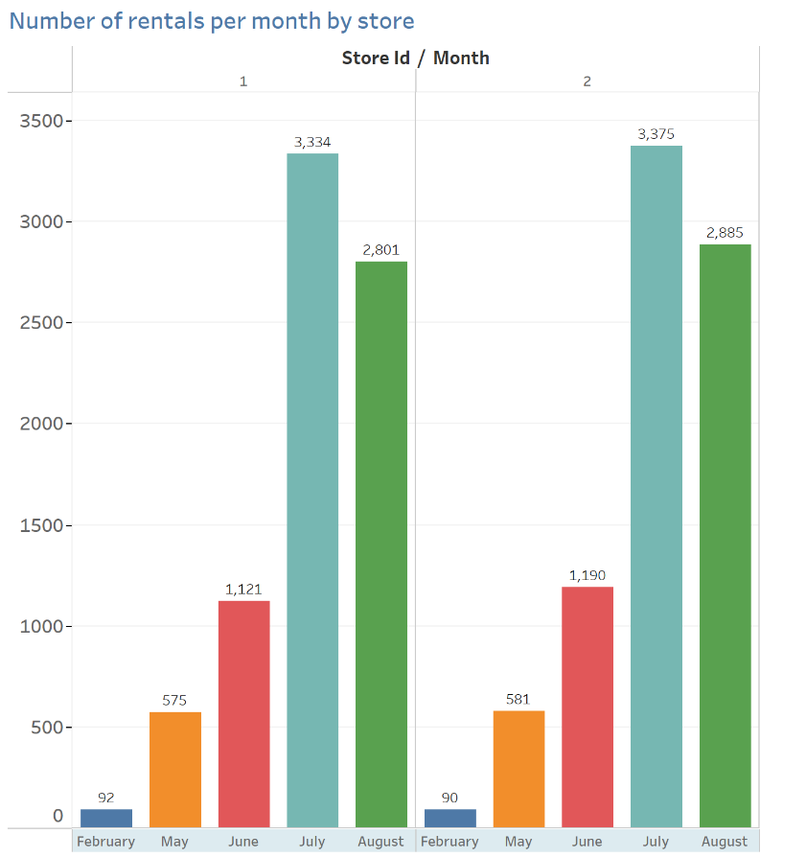

* 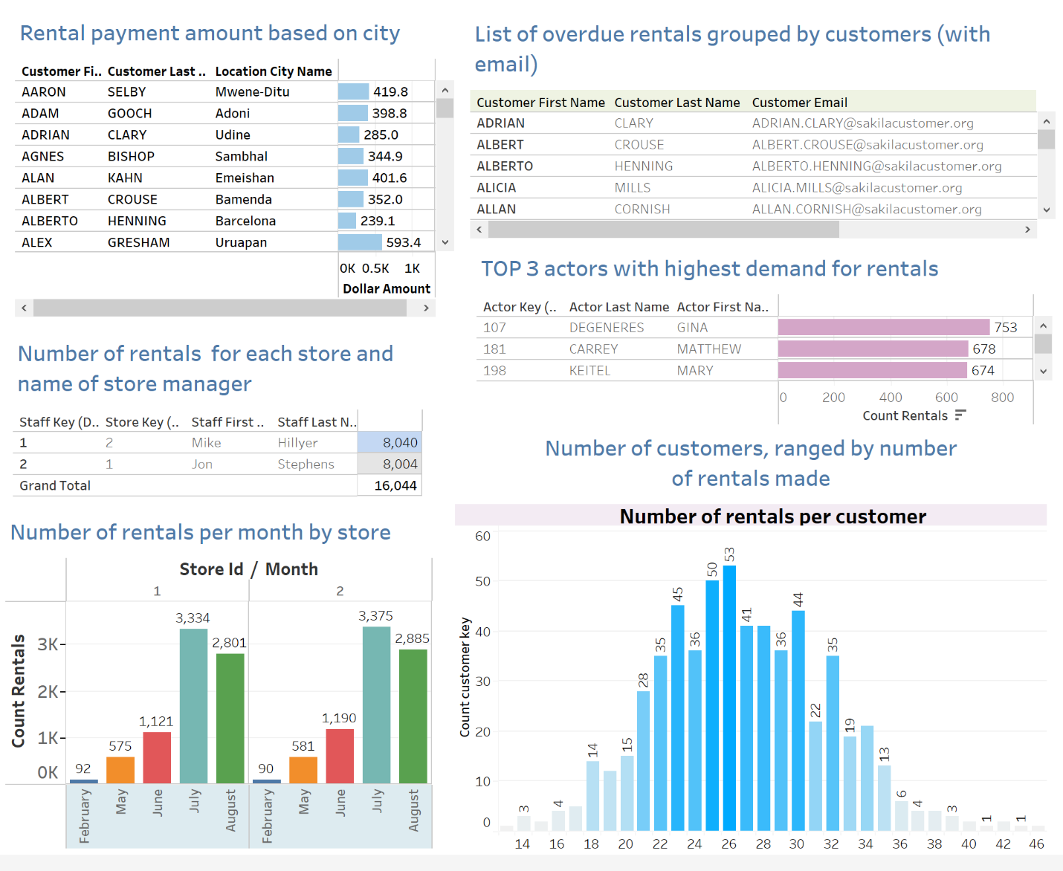**Dashboard:**